***Output view***

This is the responsive website made with Html, CSS, Bootstrap and JavaScript.

Hence, I attached both views Desktop and Mobile.

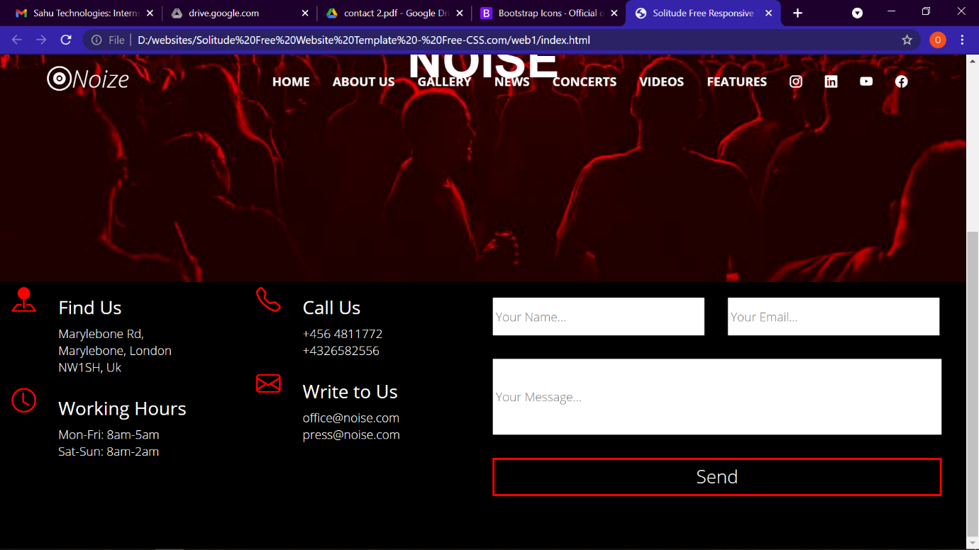 **Desktop view**

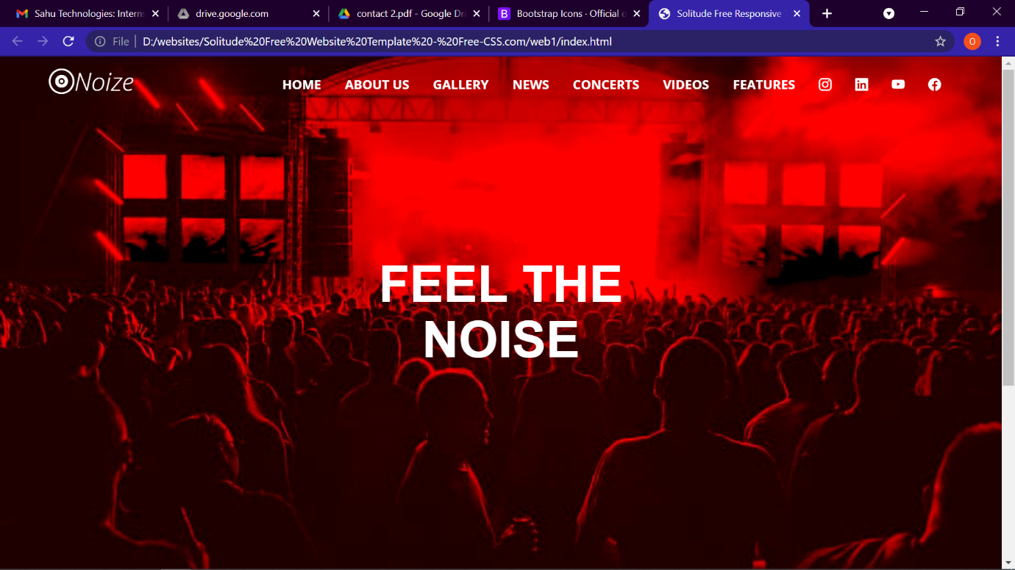

**Mobile view**

